AI Assignment 3 - 24K0546
Student Information
Name: Ismail Silat
Roll No: 24K-0546
Section: BCS-4H
Submission Date: 27 April, 2026

1. Competition Overview
- Competition Name: Predicting Irrigation Need
- Problem Type: Multiclass Classification
- Evaluation Metric: Balanced Accuracy Score
- Brief understanding of the dataset:
My target is irrigation_need with 3 classes (Low, Medium, High) so a multiclass classification would be needed with balanced accuracy (as per kaggle requirements), the dataset consists of 21 columns with the last one - target (irrigation_need), & rest as
Labels: id,Soil_Type,Soil_pH,Soil_Moisture,Organic_Carbon,Electrical_Conductivity,Temperature_C,Humidity,Rainfall_mm,Sunlight_Hours,Wind_Speed_kmh,Crop_Type,Crop_Growth_Stage,Season,Irrigation_Type,Water_Source,Field_Area_hectare,Mulching_Used,Previous_Irrigation_mm,Region,
with Soil_type (Clay, Loamy, Sandy, Silt), Crop_Type (Cotton, Maze, Potato, Rice, Sugarcane, Wheat), Crop_Growth_Stage (Flowering, Harvest, Sowing, Vegetative), Season (Kharif, Rabi, Zaid), Irrigation_Type (Canal, Drip, Rainfed, Sprinkler), Water_Source (Groundwater, Rainwater, Reservoir, River), Mulching_Used (Yes, No), and Region (Central, North, East, West, South) requiring encoding (as these are non-numerical)

2. Data Preprocessing
- Missing values handling: No missing values were found in the dataset, so no missing value handling was required.
- Encoding technique: The following required encoding as they had categorical data: Soil_Type, Crop_Type, Crop_Growth_Stage, Season, Irrigation_Type, Water_Source, Mulching_Used, Region. Label Encoding was used by assigning a unique integer to each category.
- Feature scaling: StandardScaler was applied to normalize all features to have mean of 0 & standard deviation of 1, this was necessary for distance based model (kNN).
- Train-validation split: data was divided into training & validation (with_held) set. 80% was set as training data & the other 20% for validation, making the test_size 0.2, with random_state=42 for reproducibility

3. Models Attempted
- KNN
- Naive Bayes
- Logistic Regression
- Decision Tree
- RandomForest (Advanced Model)

4. Cross Validation Strategy
- K-Fold details: k=5, All models were evaluated using 5-Fold cross validation on the data set. The data was divided into 5 equal chunks & the model was trained 5 times each time using a different chunk as the validation set. The 5 scores were averaged for the final test score.
- LOOCV observations: requires training data set for N times where N is the number of rows, the data set as 629999 rows which is computationally infeasible.
- Best validation accuracy: Decision Tree (max_depth=10) achieved the best CV score of 0.9608 ± 0.0009
5. Failed Attempts and Insights
- Model used - kNN
- Accuracy obtained
k=5: 0.4018
k=11: 0.3923
- Confusion matrix screenshot - What went wrong?
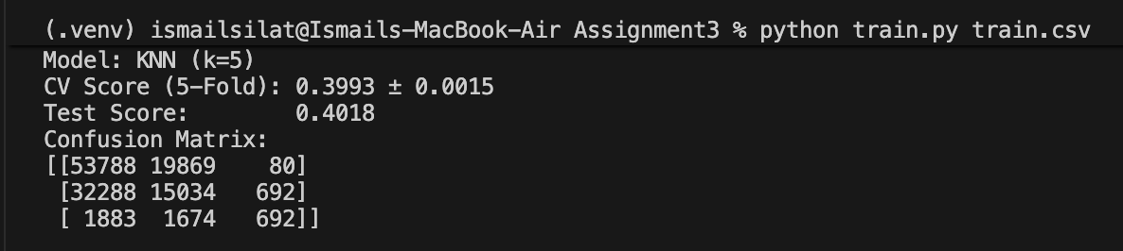
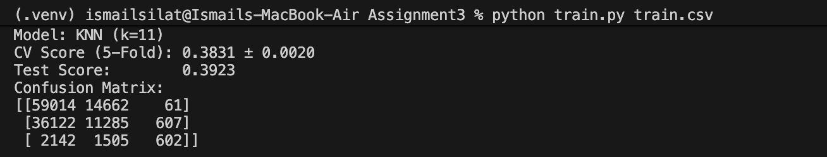
KNN performed poorly because the dataset is high-dimensional and contains both numerical and encoded categorical features. Distance-based methods struggle in such spaces, especially without feature scaling.
- What was improved?
Increasing the value of k slightly reduced noise but did not significantly improve performance. The model still remained unstable and biased toward majority classes.
- Model used - Naive Bayes
- Accuracy obtained :0.5615
- Confusion matrix screenshot - What went wrong?
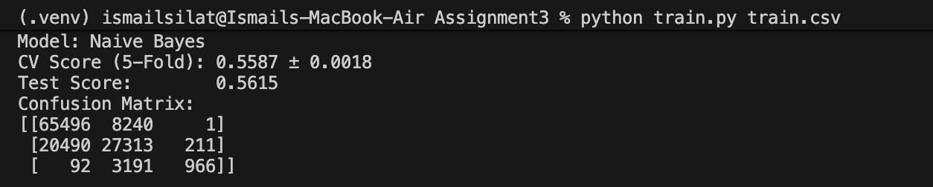
Naive Bayes assumes that all features are independent, which is not true in this dataset (e.g., rainfall, humidity, and soil moisture are related). This caused incorrect probability estimations.
- What was improved?
Despite its simplicity, Naive Bayes performed better than KNN, but still failed to capture complex relationships between features.
- Model used - Logistic Regression
- Accuracy obtained: 0.5381
- Confusion matrix screenshot - What went wrong?
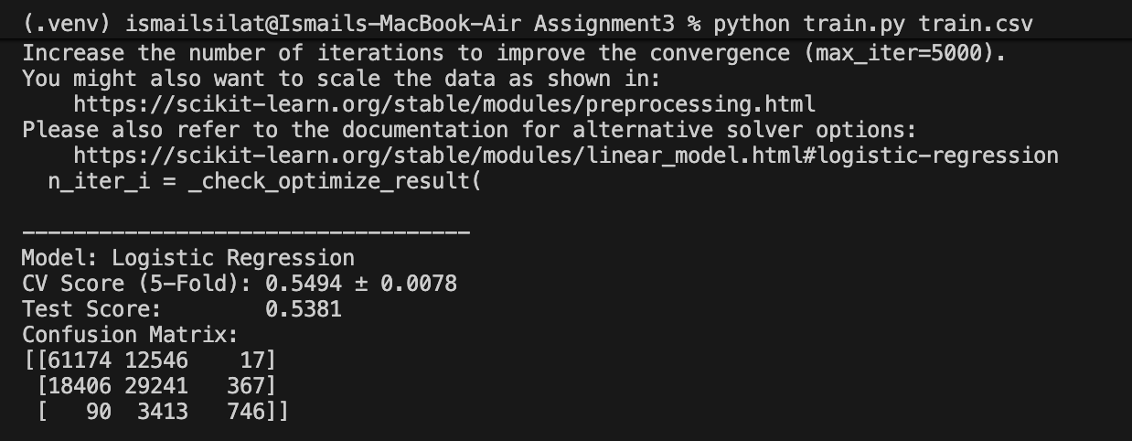
Logistic Regression struggled due to non-linear relationships between features and class labels. Additionally, convergence warnings indicated that the model did not fully optimize due to lack of feature scaling.
- What was improved?
Increasing maximum iterations improved stability slightly, but performance remained limited.
- Model used - Decision Tree
- Accuracy obtained
Default: 0.9447
Depth = 10: 0.9593 (better result)
Depth = 7 (tuned): 0.9619 ( best result)
- Confusion matrix screenshot - What went wrong?
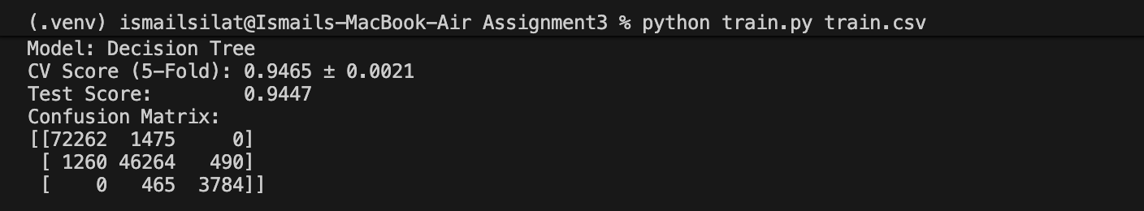
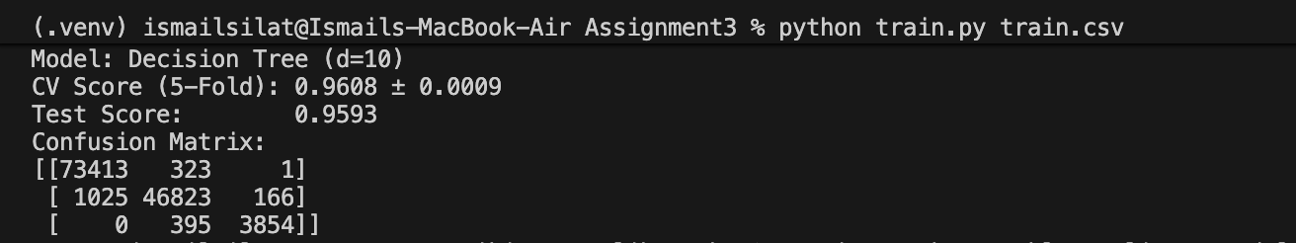
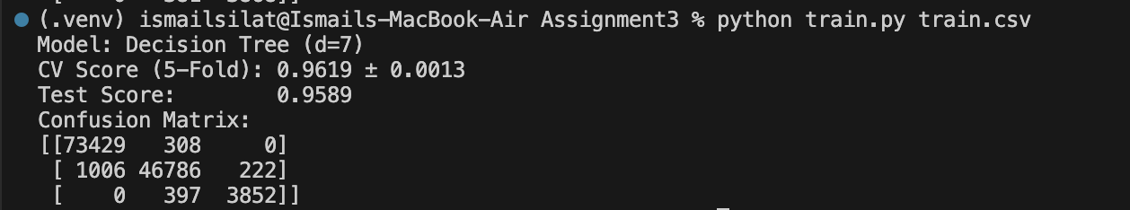
Default decision trees tend to overfit when depth is unrestricted.
- What was improved?
Hyperparameter tuning via RandomizedSearchCV on additional parameters (min_samples_split, min_samples_leaf, criterion, max_features, min_impurity_decrease) with depth fixed at 7 yielded the best overall result.
- Model used - Random Forest
- Accuracy obtained: 0.9562
- Confusion matrix screenshot - What went wrong?
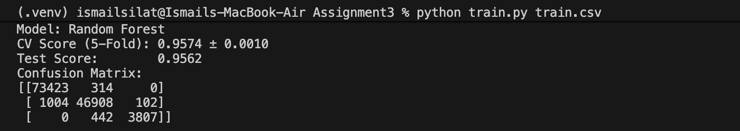
Although Random Forest performed strongly, it did not outperform the tuned Decision Tree in this case.
- What was improved?
Ensemble learning improved stability compared to a single tree, reducing variance in predictions. Further hyperparameter tuning (e.g. n_estimators, max_depth, max_features) was not pursued due to the high computational cost of training multiple trees on 630,000 rows, which made exhaustive search impractical within time constraints.
6. Final Model Selection
Best model: Decision Tree Classifier (max_depth = 10)
- Hyperparameters
max_depth = 7
min_samples_split = 5
min_samples_leaf = 8
min_impurity_decrease = 0.0
max_features = None
criterion = entropy
random_state = 42
- Why selected?
This model was selected because it achieved the highest balanced accuracy score (0.9619) among all tested models. It also showed; strong performance across all three classes (Low, Medium, High), reduced overfitting compared to an unrestricted decision tree, and better generalization than Logistic Regression, Naive Bayes, and KNN. Compared to Random Forest, it performed slightly better while being simpler and easier to interpret with lower computational costs. Hyperparameters were found using RandomizedSearchCV over 20 random combinations, searching on a 30% stratified sample of training data for efficiency.

7. Leaderboard Performance - Kaggle score
- Rank 2738
- Screenshot attached
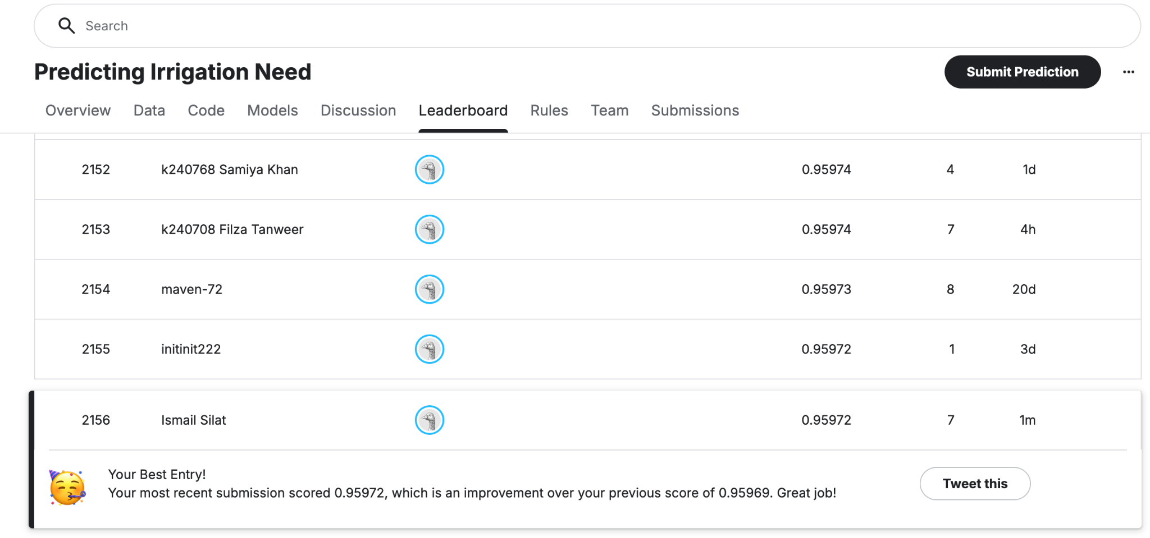
Submission with name: Ismail Silat
8. Conclusion and Learnings
- Key insights
This project demonstrated that tree-based models are highly effective for multiclass classification problems involving mixed numerical and categorical features. Decision Trees and Random Forests outperformed linear and distance-based models.
- Challenges faced
- Encoding multiple categorical variables correctly
- Ensuring fair comparison across models
- Handling convergence issues in Logistic Regression
- Interpreting confusion matrices for multiclass outputs
- Future improvements
- Applying feature scaling to improve Logistic Regression performance
- Using advanced ensemble models
- Performing hyperparameter tuning
- Exploring feature selection to reduce noise and improve generalization

